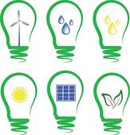
Energy Conservation
Use p.86 of Pearson Science 7 Student Book to answer the following questions:

1. Using Figure 3.2.12, which area of the Earth is best for the use of solar energy technologies, the poles or the equator? ______________________________________
(1 mark)

2. Use data from Figure 3.2.12 to justify your choice _______________________
_____________________________________________________________________
_____________________________________________________________________
(1 mark)

3. What is the average wave flux in the area around southern Western Australia and South Australia? ____________________________________________________
(1 mark)

4. Which two continents have the world’s largest renewable electricity plants? _____________________________________________________________________
(2 marks)

5. Name one area of the world with average wind speed over 29km/h __________
_____________________________________________________________________
(1 mark)

6. Of the 4 energy types presented in Figure 3.2.12 which would be suitable for Australia to develop? ____________________________________________________
_____________________________________________________________________
(1 mark)

7. At current production rates, which renewable energy source is utilised the most? _____________________________________________________________________
(1 mark)

8. Why does recycling goods help to conserve energy? ______________________
_____________________________________________________________________
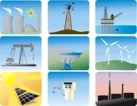
_____________________________________________________________________
(1 mark)

